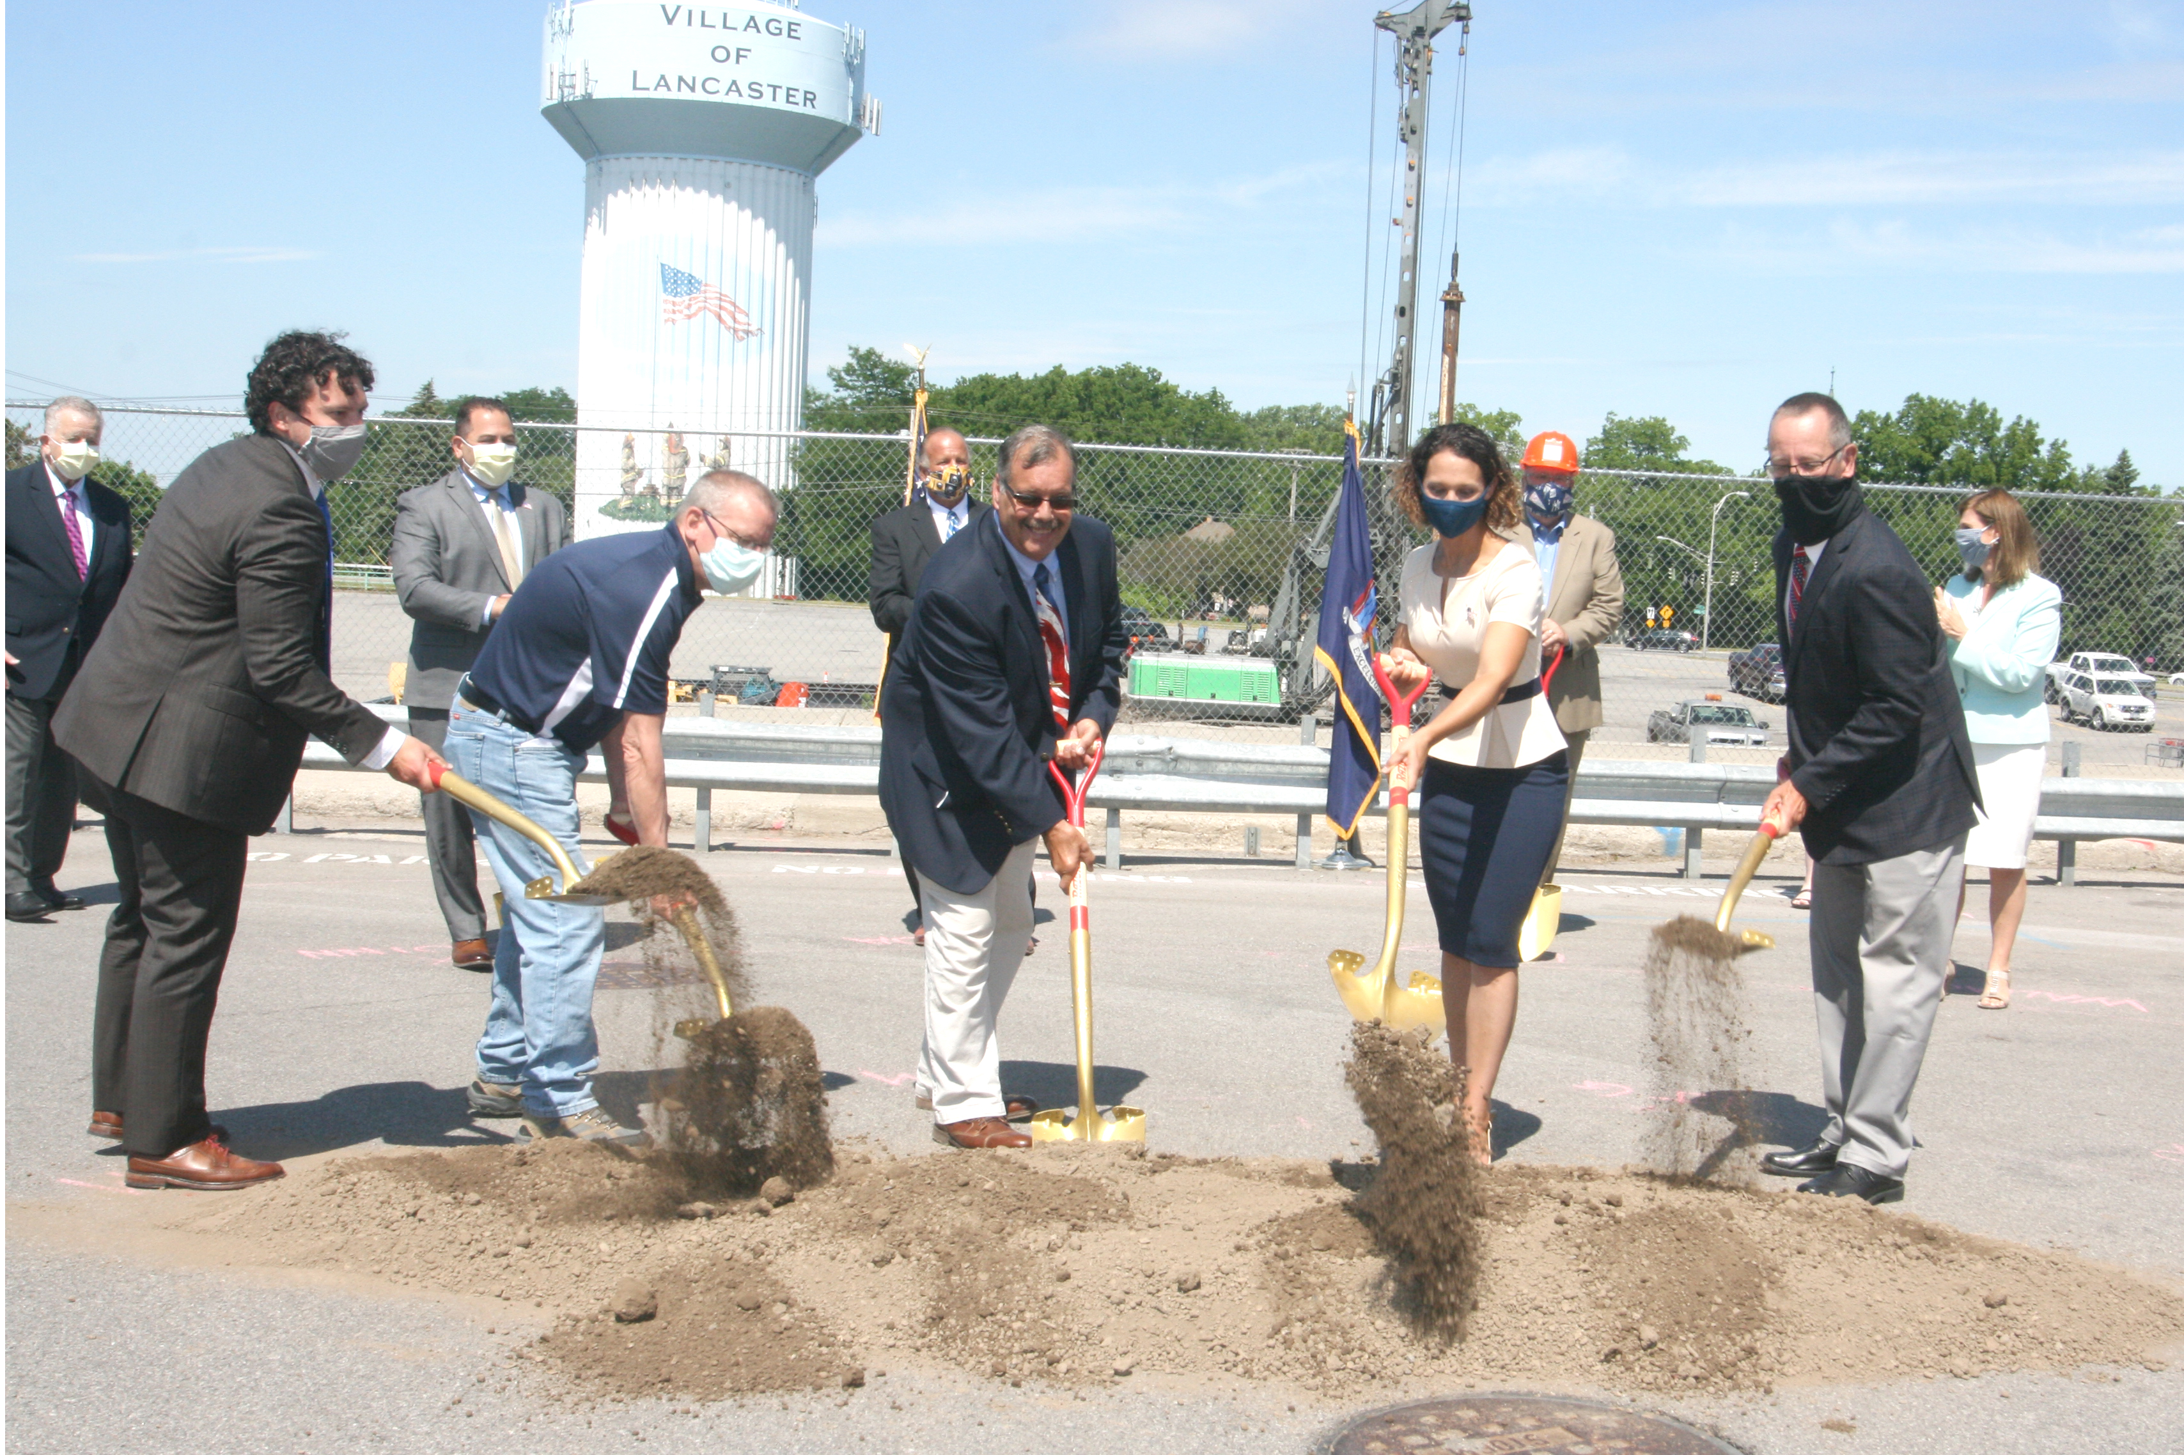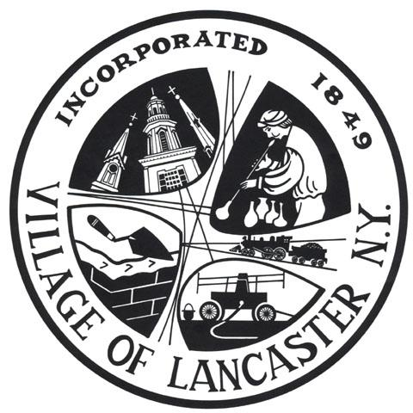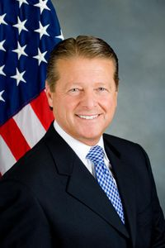

Senator Patrick M. Gallivan (R-C-I, Elma) is announcing his office has secured an additional $2.5 million in state funding to support creation of a downtown village center in Lancaster. The redevelopment project calls for extensive infrastructure improvements designed to complement the downtown business district.

"These additional funds will support the village’s plan to improve traffic flow and pedestrian safety by creating a new streetscape through the main business district,” Senator Gallivan said. “State support of this ambitious project will allow work to proceed without placing an additional financial burden on local taxpayers. In the end, the improvements will enhance conditions for residents, businesses and visitors.”

The redevelopment project includes the creation of roundabouts at Central Avenue and Pleasant Avenue and North Aurora Street and West Pleasant Avenue, the reconstruction of Pleasant Avenue West, construction of the West Main Street extension, and a park along Cayuga Creek.

The $2.5 million is in addition to $3.1 million in funding announced in 2019 for the roundabouts at Pleasant Avenue and Central Avenue and North Aurora Street and West Pleasant Avenue.

The final project is designed to reduce traffic congestion, reduce vehicle emissions, and improve pedestrian and bicycle safety. The design also includes new landscaping and parking.

**SENATOR GALLIVAN ANNOUNCES ADDITIONAL FUNDING FOR VILLAGE OF LANCASTER REDEVELOPMENT PROJECT**

*$2.5 MILLION TO HELP CREATE VILLAGE CENTER*

Stay informed and become involved in your community!

The Lancaster Villager

**Facebook** 

VillageofLancasterNY

**Instagram **

LancasterVillageNY

**Twitter **

@LancasterVill

**Follow us**

**On Social Media!**

**Social Media!**

During the course of the next few years, the Village of Lancaster will be taking on some ambitious projects in the Central Business District. While change can be intimidating & construction can be tedious, the growth & expansion of the Central Business District will breathe new life into the Village. Stay updated on all of the projects by visiting the village website [www.lancastervillage.org](http://www.lancastervillage.org). We hope that you will stay informed during this exciting time in our village’s history!

### A Vision for the Future

Garage Sale permits are free of charge however, mandatory. You can get one

M-F in the Village Clerk Office (5423 Broadway) or you can apply for one online at our website and the permit will be mailed to you. Social Distancing guidelines must continue to be followed and masks must be worn at all times.

www.LancasterVillage.org

##### Please make sure you apply for a permit

##### 

#### **Interested in Having a Garage Sale?**

**summer 2020** **Volume 3, Issue 2**

**West Main Street Project**

The Village of Lancaster envisions the Central Business District as a vibrant, mixed-use destination providing opportunities for a “Shop, Stroll, Stay” experience for both residents and visitors. The West Main Street Extension Project represents a public realm investment that will stimulate this vision. This project includes these elements:

* Complete street design to accommodate vehicles, pedestrians, bicycles, parking and streetscape
* Extension of West Main Street to Aurora Street. Conversion from one-way street to two-way
* Improvements to West Main Street/Center Avenue intersection. Addition of mini-roundabout at new intersection of West Main Street/Aurora Street.
* 11 foot shared vehicle/bicycle travel lanes, 8 foot parallel parking lanes on both sides of the street, pedestrian components
* Street trees, light poles, landscape amenities (benches, planters)
* Wayfinding and interpretive signage
* Utility relocations and upgrades (including sanitary sewer, storm sewer, waterlines, gas lines)

**IMPORTANT CONSTRUCTION UPDATES**

* **West Main St will be closed to vehicles beginning the week of July 13th but will be open to pedestrians and our businesses will remain open throughout construction**
* **North Aurora St will be shut down at the construction site and a detour route will be marked.**

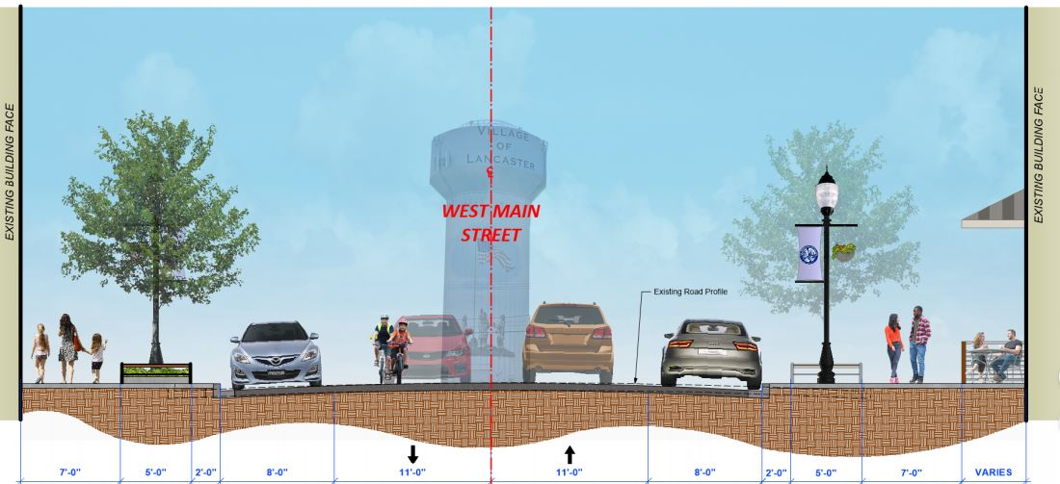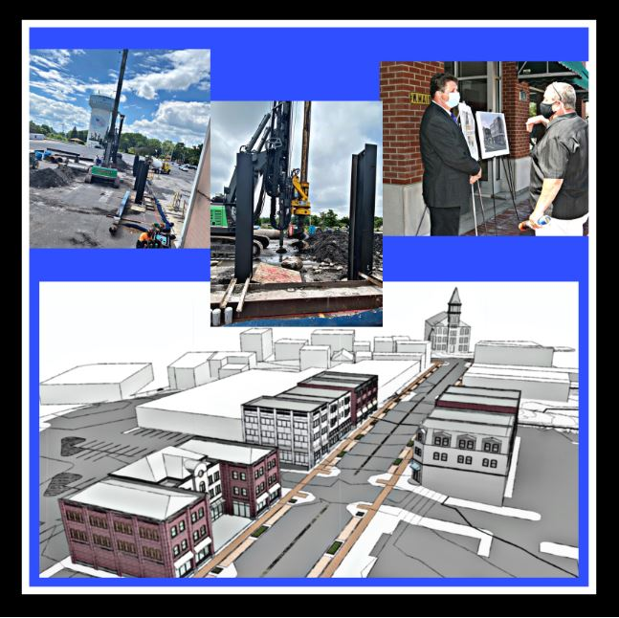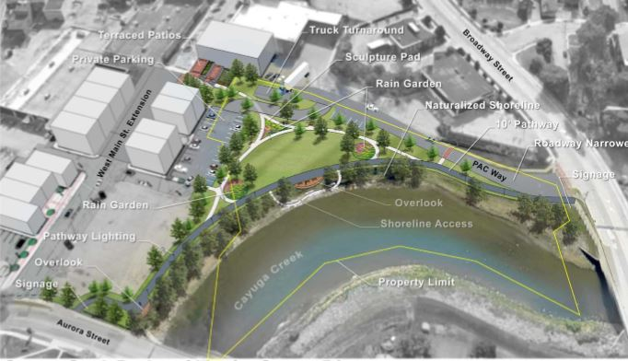

**Please support our local businesses during construction on W. Main!**

______________________________________________

Aurora Imprints

Bloomsbury Lane Toy Shoppe

Dark Forest Chocolate

Furry Friends

Gilded Maple

Lilly Belle Meads & TIL Brewing

Purely Pets

Save-a-lot

The 716 Dance Lab

The Lancaster New York Store

Whole Fitness

WNY Music Academy

______________________________________________

**Where can I park?**

* Clark Street
* Central Ave Street Parking
* Central & Broadway Lot
* Save- a – lot parking lot

The Building Department is located at 21 Central Ave.  Hours of operation are Monday - Friday, 8am-5pm and can be contacted at (716) 684-4171.  Please contact this dept. for information & specifications regarding set back, permitted size and height of structures, prior to permit application submittal.  You can also visit our website [lancastervillage.org](http://www.lancastervillage.org) to view village codes.  Some examples of required work permits are as follows:  shed, garage, fence, pool, deck and demolition.

The Central Avenue Corridor Improvement project is a transformative project for cyclists, pedestrians and motorists alike.  Proposed improvements will be implemented along Central Avenue from Walden Avenue to Pleasant Avenue. The project design involves traffic calming measures, bicycle lanes, and consideration for some corridor lighting improvements.  Funding for the project was awarded to the Village through a Community Development Block Grant (CDBG) as part of Erie County’s Smart Growth program.

Bicycle lanes, made possible through a process known as a road diet, is the most notable improvement. A road diet simply takes the distance between the curb lines on an existing roadway and repurposes the space between the curb lines.  This process serves two advantages, it improves the safety of all traveling public, by reducing the width of vehicle travel lanes which naturally slows down traffic, and it allows for bicycle lanes to have their own dedicated lanes separate from other vehicles.

These improvements will all be managed through pavement striping along the road.  The new striping will delineate each feature of the roadway including a single lane of vehicular traffic in each direction, a bicycle lane in each direction adjacent to the travel lanes, as well as vehicular parking and turning lanes where warranted. This encompasses over ¾’s of a mile of new bicycle lanes between Walden and Pleasant Avenue.

The Central Avenue Bike Lanes bid was opened in June 2020 and the village awarded the project. Construction should commence in early August, removing old striping & adding new striping to create bike lanes on Central avenue between Walden and Pleasant.

Here's a link to a video explaining a Road Diet.

[https://www.youtube.com/watch?v=LSJp8Ht-0RU](https://urldefense.proofpoint.com/v2/url?u=https-3A__www.youtube.com_watch-3Fv-3DLSJp8Ht-2D0RU&d=DwMFAw&c=euGZstcaTDllvimEN8b7jXrwqOf-v5A_CdpgnVfiiMM&r=CpXqefhNP-AAZt0aWMukdmldhhUaJPqqQb23kz5FhhY&m=ND9TQ01dKPjMRb2yuXzLQzuyUgPa6zi2uGnWqt-j92A&s=Wv9Sz8DrYjTGYOa2WXnV9GBn37l_-BFkTlM41RIUlps&e=)

The Cayuga Creek Park project is an urban pocket park that will provide beautification to the bank of Cayuga Creek, a public gathering space, vegetated areas with rain gardens, pedestrian connectivity between Aurora Street & Broadway and the possibility of lighting throughout the park.  The project is located in the Village south of the proposed West Main Street Extension and North of Broadway along Cayuga Creek.  The project is partially funded by a 500k grant from the Dormitory Authority of the State of New York (DASNY).

To make the project possible parcels of private property need to be transferred to Village ownership. This is a very unique opportunity for the Village and a great example of how working together can yield positive results and improvements for the entire community.

A pathway will be installed the length of the project, allowing pedestrians to safely travel the beautified banks of Cayuga Creek between Broadway and Aurora Streets. This will include great overlook locations to enjoy the water.  A portion of the project does reside in the 100yr flood plain. The design team at CPL who is currently designing the project will consider the potential impacts this may have on the park and will implement best practices into the design wherever possible. The design also includes green infrastructure, with the consideration of bioswales and or rain gardens, a great example of how the Village is striving to go green with its infrastructure investment and improvements.

Additional improvements for new park lighting are also being considered throughout the park.  The environmental review process has been completed. The Village of Lancaster continues to coordinate work between the private developers along W. Main Street as the Village is developing plans for the Cayuga Creek Park and trail project.   The project may be expanded to include electrical service and lighting for the entire park as well as a terraced “green space” where Pac Way currently runs up to main street.  The project will be bid this fall or winter for construction next spring.

**Bike Lane Project**

**Remember to Obtain a Permit for Upcoming Projects**

**Cayuga Creek Park Project**

As the weather begins to warm up and home projects begin, please remember to obtain a permit before the work begins. Per Village Code; “Before any person shall erect, construct, alter, move, demolish or commence to erect, construct, alter, move or demolish any building or structure within the Village of Lancaster, such person shall first apply for & obtain a building permit from the Building Inspector.”

**Letter from**

**Mayor Schroeder**

Dear Lancaster Village Residents,

 On behalf of the Lancaster Village Board, I'd like to extend my appreciation to you for your help & support during this Pandemic. As we emerge from this crisis, I am proud to see our local businesses begin to come back to life. It's nice to see people driving back to work each day and it's especially great to see the W. Main Street Extension Project break ground!

This is an exciting time for our Village. For almost 50 years, Residents have been waiting for "something" to happen with the "The BOCES lot" and finally, through a combination of diligence, planning, hours of meetings, presentations & the full support of the Village Board, this project has begun. This project should progress rather rapidly. As with any construction project, there will be some inconveniences however; those will be kept to a minimum for all involved. We look forward to the progress of these projects so that development of that property may begin. If you have questions or concerns, please feel free to contact me at 583-4076. Please have a happy and safe summer!

*William C. Schroeder*

*Mayor*

*Village of Lancaster, NY*

The improvements to Hadsall Park and the Spray Pool continue this summer. The new water line, automated water valve, hot box, minor lighting & power are now installed. The sidewalks and parking lot are currently being built to make it more

of a family destination.

Unfortunately, the opening of the Spray Pool is delayed due to the current pandemic. With social distancing requirements, most municipal pools and splash pads remain closed, including the Hadsall Park Spray Pool.

*Funding for this project was obtained through Assembly woman Monica Wallace’s office.

**Hadsall Park Spray Pool**

**Clerk – Treasurer Office & Main Village Contact**

Michael E. Stegmeier

5423 Broadway

Lancaster, NY 14086

(716) 683-2105

mstegmeier@lancastervillage.org

**Village Board Meeting Dates**

The Village Board meets on the 2nd & 4th Monday of the month at 7pm on the 2nd Floor of the Municipal Building at 5423 Broadway or on zoom. Info always posted on website.

Monday, July 27th

Monday, August 10th

Monday, August 24th

Monday, September 14th

Monday, September 28th

Monday, October 12th

Monday, October 26th

Monday, November 9th

Monday, November 23rd

|  |  |
| --- | --- |
| Important Contact Information | |
| Mayor William C. Schroeder | wschroeder@lancastervillage.org |
| Trustee Paul M. Maute | pmaute@lancastervillage.org |
| Trustee Joseph E Quinn | jquinn@lancastervillage.org |
| Trustee Lynne T. Ruda | lruda@lancastervillage.org |
| Trustee Paul H. Rudz | prudz@lancastervillage.org |
| DPW Superintendent William Cansdale | wcansdale@lancastervillage.org |
| Code Enforcement – Shawn Marshall | smarshall@lancastervillage.org |
| Fire Inspector and OEM – Scott Kuhlmey | skuhlmey@lancastervillage.org |
| Fire Chief - Mark Stonebraker | mstonebraker@lancasterfd.org |
| Events Coordinator | events@lancastervillage.org |
| Village of Lancaster Justice Court | 716-683-6780 |

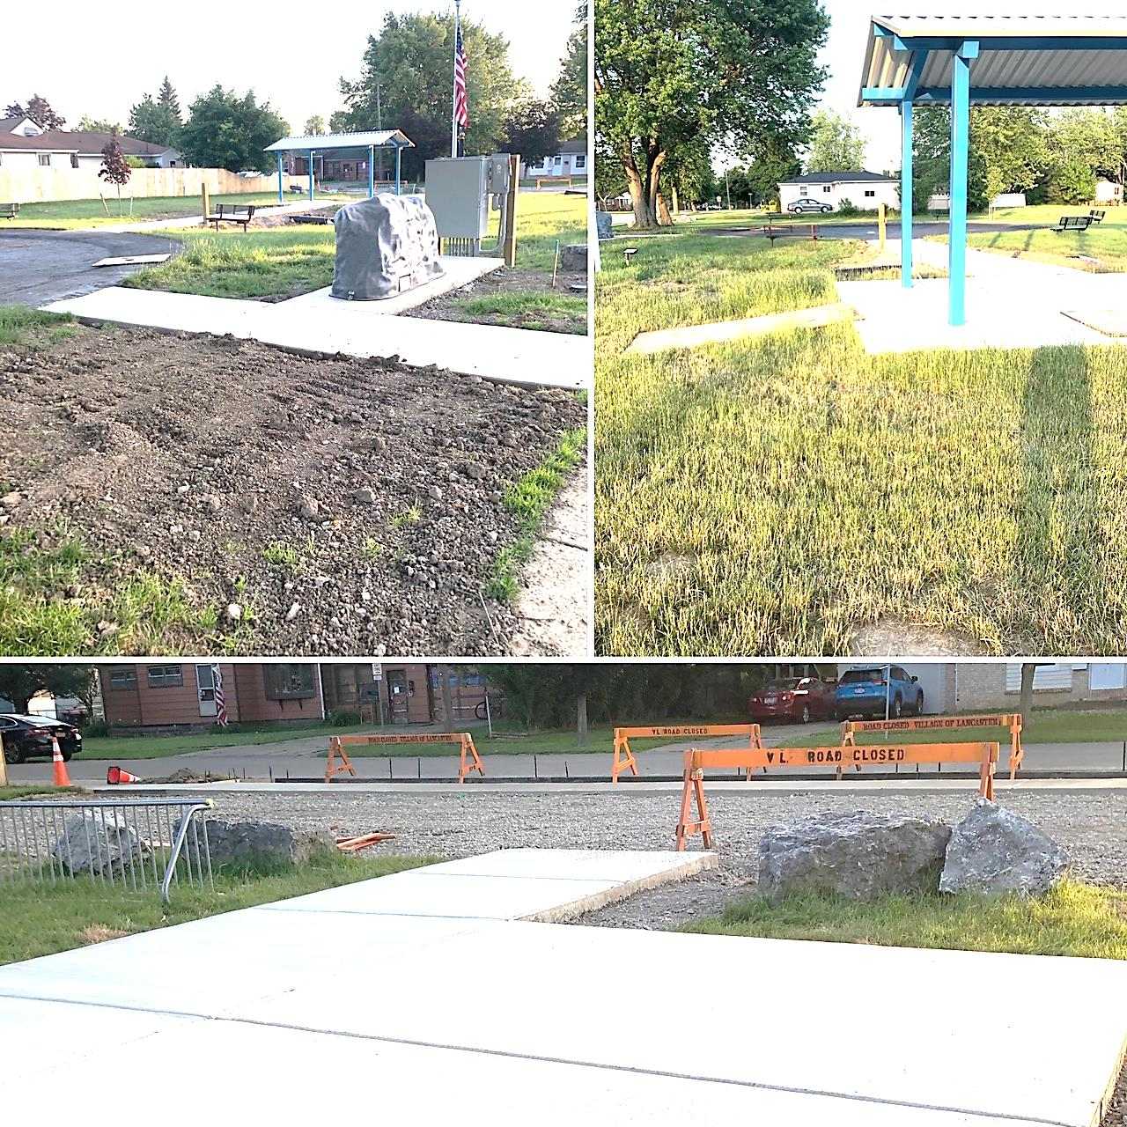

Mayor Schroeder and the Village Board would like to thank our out-going Events Coordinator, Dawn Gaczewski for the wonderful job she has done in her 7+ years serving the Village. There is much planning, organizing and many details in running large scale community events and other than weather related problems, our Events were well attended, cost efficient and enjoyed by thousands. These are big shoes to fill. Dawn had brought her own style & creativity to the events series, from creating Zombieville & Christmasville, designing the winter window displays and getting the Village of Lancaster Events on the map!

**Thank you Dawn Gaczewski**