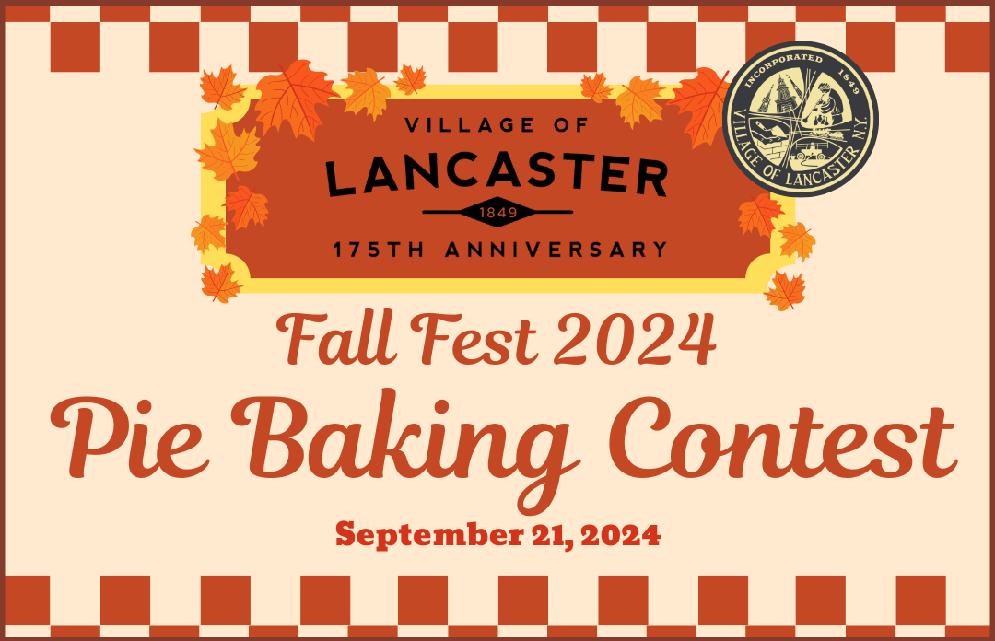

The Village of Lancaster 175th Anniversary Committee is excited to host a pie baking contest as part of Fall Fest on September 21, 2024! Contestants are invited to show off their pie-baking skills and win prizes! A panel of judges will grade submissions on appearance, crust quality, filling, and flavor.

To enter the contest, bring your homemade pie to the Pie Baking Contest tent at Fell Fest between 11:00 AM and 1:00 PM and register. Any pies submitted after 1:00 PM will not be eligible to compete. Judging will take place from 1:00 PM to 3:00 PM, with the winners announced at the end of judging. Participants must be present to claim their prize.

CONTEST RULES & REGULATIONS

This contest is open to amateur bakers only. Professional bakers—defined as individuals who work for or own a bakery, catering business, or sell pies—are not eligible to compete.

There is no entry fee for the contest.

The pie must be made by the individual submitting it and baked in a 9” covered, disposable pie tin or plate. Do not label the pie tin with your name. Each pie will be assigned a number at registration to ensure anonymous judging.

An ingredient list must be provided with your pie.

Both the crust and filling must be homemade. Store-bought crusts, dough, or canned fillings are not allowed.

Pies must not require refrigeration and cannot contain raw or uncooked eggs (whites or yolks).

Only one pie entry per contestant.

The contest will take place rain or shine.

JUDGING

Judges will not know the identity of the pie bakers.

Judging will begin at 1:00 pm with prizes announced at approximately 3:00 pm.

Judges will independently assign each pie a score.

In case of a tie, the higher Flavor/Taste score is the first tiebreaker. Otherwise, judges will judge those pies again.

All judges’ decisions are final.

Judges will score pies based on 4 criteria:

Appearance: 10 points

Crust: 20 points

Filling: 20 points

Flavor/Taste: 50 points

Total possible points: 100

PRIZES

1st Place - $100 gift certificate to Gilded Maple!

2nd Place - $50 gift certificate to Skoob’s Village Grille!

3rd Place - $25 gift certificate to Gabrielle’s Bakery!